Stitch-agnostic, technique-aware data model for digital embroidery pattern design

Abstract. Digital embroidery tools have traditionally relied on data models that define stitches by type, closely mimicking the human perception of distinct stitch forms. While intuitive, this approach limits flexibility - particularly in visualization and data manipulation. This paper introduces a stitch-agnostic, technique-aware data model that represents embroidery patterns as sequences of dot indexes on a matrix. By defining needle paths through matrix indexes rather than categorizing stitch types, the model offers a stitch-independent and technique-aware representation of embroidery patterns. Unlike type-based models, this approach allows almost any stitch form - existing or newly invented - to be described without requiring modifications to the model or supporting software.

- Introduction
Digital embroidery software has evolved significantly over the past 30 years. From early desktop tools in the 1990s to today’s mobile-based and web-based platforms, a wide range of applications have emerged — and many have vanished. Most of these tools used proprietary binary formats, which made the designs inaccessible outside their original environments. As software aged or became unsupported, entire pattern libraries became unusable. This reliance on closed formats created long-standing issues for preservation, tool interoperability, and creative continuity.
In response, newer formats like OXS (open cross stitch file format) have aimed to improve transparency and accessibility. OXS is an open-source and human-readable file format which uses XML to describe pattern content in a structured way. This represents significant progress compared to legacy formats. However, OXS remains stitch-type based — each stitch must conform to a predefined type such as full cross stitch, back stitch, or fractional stitch. While this model is intuitive for human designers, it limits flexibility - adding a new stitch type requires updates across all supporting applications and tools.
The proposed data model offers a fundamentally different approach. Rather than classifying stitches by name or type, it describes embroidery patterns as ordered sequences of indexes (needle paths) on a logical grid representing the fabric. This matrix-based, stitch-agnostic and technique-aware model captures what the needle does, rather than what the stitch is called.
Crucially, following the exact path of the needle means that the underlying embroidery technique is also captured. This allows software not only to render the front side of a pattern, as all current tools do, but also to simulate the backside, revealing how the thread moves across the fabric. Additionally, an animation illustrating the embroidery process step by step can also be created. These capabilities open up new educational, aesthetic, and technical applications, especially for analyzing and teaching embroidery techniques.

- The OXS format: a stitch-type based approach
OXS has an XML-based file structure designed to represent cross-stitch patterns digitally (see Figure 1).

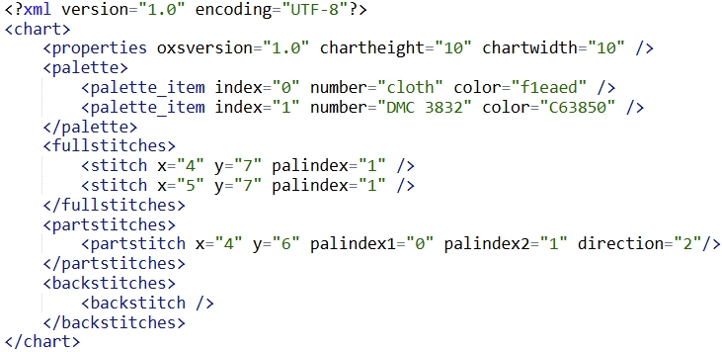
Figure 1.
OXS organizes a pattern into key components that define the chart, colors, and stitch placements. Each pattern is defined within a <chart> root element and organized into several key sections:
- The <properties> element specifies global metadata about the chart:
- oxsversion: The version of the OXS specification.
- chartheight and chartwidth: Defines the dimensions of the stitch grid.

- The <palette> defines the threads used in the design. Each <palette_item> has:
- index: A numeric reference to be used elsewhere in the pattern.
- number and name: Human-readable identifiers (e.g., DMC code and color name).
- color: A hexadecimal color code used for rendering.

- The <fullstitches> section contains <stitch> elements representing complete cross stitches. Each stitch is positioned by its grid indexes x and y and references a color via palindex.

- The <partstitches> section element defines stitches that cover part of a square. A <partstitch> includes:

- x, y: Grid position.
- palindex1 and palindex2: Two color references.
- direction: Indicates stitch orientation (e.g., top-left to bottom-right).

- Backstitches: The <backstitches> element holds lines outlining or detailing the pattern, though it is empty in this example.

The OXS format supports a wide variety of stitch types beyond full cross stitches, including quarter stitches, tent stitches, French knots, beads of various sizes, and complex shapes like queen3x3 diamond motifs and triangular stitches.
It is up to the specific software implementation to determine how each stitch type is visualized, as the OXS format defines only the stitch type and associated metadata—such as direction or size—without enforcing a particular rendering or appearance.
Stitches in the OXS format are positioned using grid indexes, where the x and y attributes specify the stitch’s exact location on the pattern’s rectangular grid, see Figure 2.

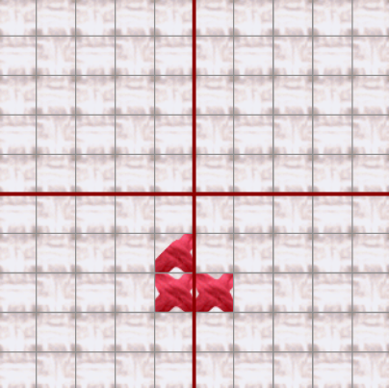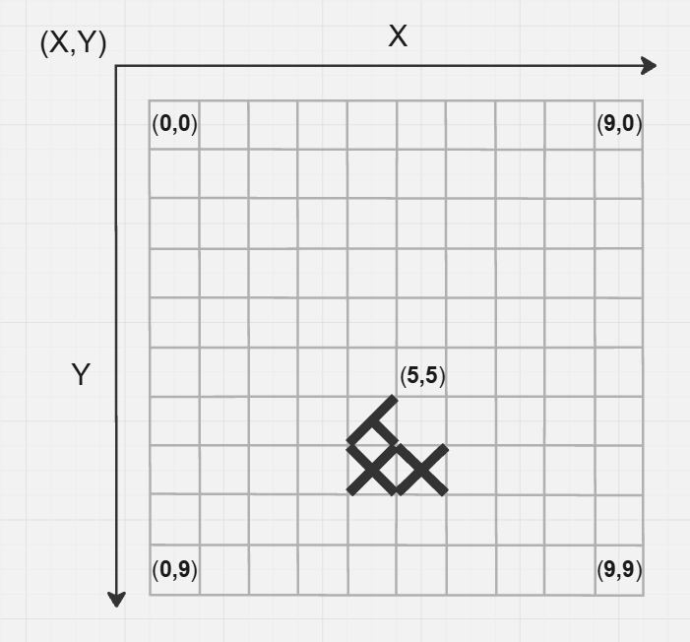
Figure 2.

- Stitch-agnostic, technique-aware data model.
In contrast, the stitch-agnostic, technique-aware model proposed in this paper adopts a lower-level abstraction. This data model has a JSON-based file structure designed to represent cross-stitch patterns digitally. It does not rely on naming or categorizing stitch types. Instead, it captures embroidery as a sequence of needle movements — a path traced through a set of discrete points (or "dots") arranged on a logical fabric grid. This path is encoded using coordinate sequences: arrays of horizontal (indexesX) and vertical (indexesY) indexes, which are traversed in order (see Figure 3).

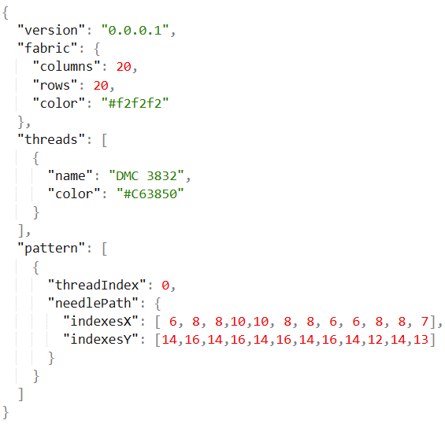
Figure 3.

The proposed data model organizes an embroidery pattern into key components that define the fabric, threads, and pattern:
- The fabric property describes the canvas/grid on which stitching occurs:
- columns and rows: Defines the dimensions of the grid.
- color: Background color of the fabric.

- The threads property defines the threads available for stitching the pattern:
- name: Label or code (e.g. "DMC 321"`)
- color: Hex or named color string

- The pattern property describes the needle paths that form the design. Each array item consists of:

- threadIndex: Index of the thread used from the `threads` array
- needlePath: Sequence of dot positions (indexesX[i], indexesY[i]) visited in order

The model separates data (see Figure 4) and rendering (see Figures 5 and 6), focusing on logical stitch paths — leaving interpretation (like visual rendering or semantic meaning) to the engine or UI.

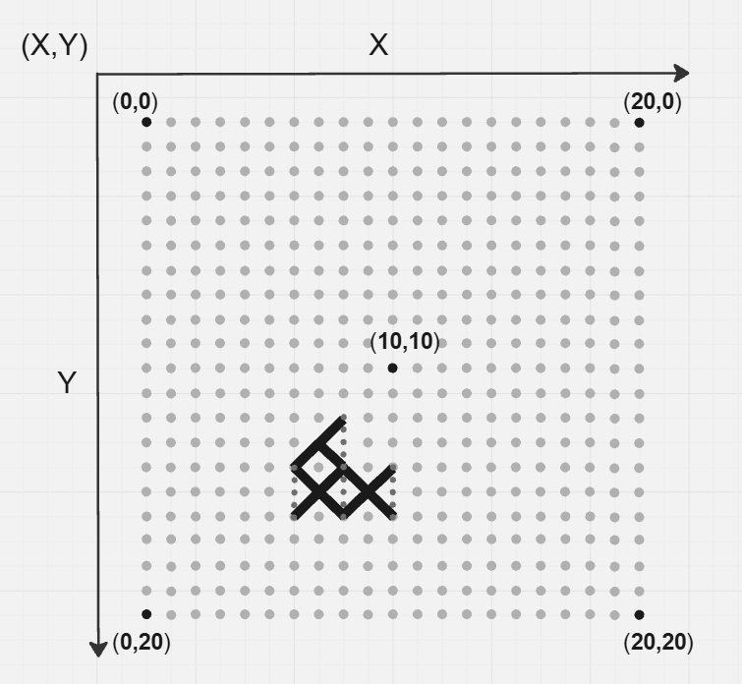
Figures 4.

Figure 4 illustrates a needle path composed of 12 pierced grid points (referred to as “dots”). Solid lines indicate segments of thread visible on the front side of the fabric (see Figure 5), while dashed lines correspond to segments on the back side (see Figure 6). The needle path encodes a complete stitching action and can be interpreted as follows:
- The needle begins on the back side of the fabric. This initial insertion is implied and not explicitly encoded in the pattern array.
- The first visible action is the needle emerging on the front side at grid coordinate {x: 6, y: 14} .
- The needle is then pulled to the back side at {x: 8, y: 16}, forming the first front-side stitch segment.
- It reappears on the front at {x: 8, y: 14}, creating a back-side stitch segment between the previous exit and this entry.
- This alternating sequence continues for the full duration of the path, encoding the precise physical motion of stitching.

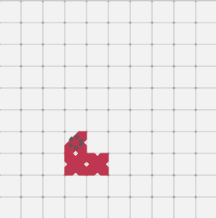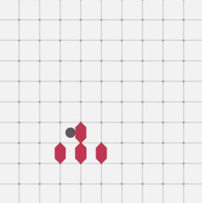
Figures 5 and 6.

Describing a pattern as a sequence of grid points (dot indexes) allows for the representation of not only standard stitches but also lesser-known embroidery techniques. For example, it becomes possible to capture unique decorative motifs found on traditional blouses from the Vidin region (see Figures 7 and 8).
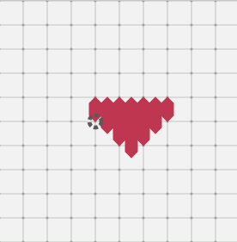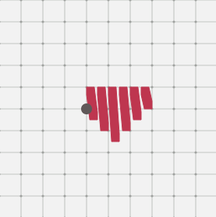
Figures 7 and 8.

The resulting needlePath is described just by another set of indexes (see Figure 9), eliminating the need to introduce a new stitch type or extend the schema.

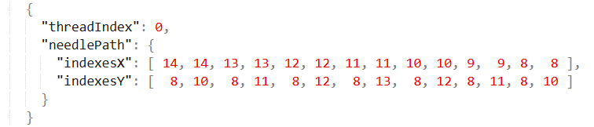
Figure 9.

It is important to note that not all dots defined in the data model need to be rendered as visible holes in the user interface. As demonstrated in Figures 5, 6, 7, and 8, some grid points can remain hidden to preserve visual clarity and avoid overwhelming the representation with excessive detail.

- Stitching Animation and Interactive Playback
The proposed stitch-agnostic, technique-aware data model enables a range of dynamic visualizations, including interactive animations that closely mimic real-world stitching processes. By following the exact sequence of indexed needle movements, software can render the progressive buildup of a pattern—step by step—on both the front and back sides of the fabric. This opens the door for an experience akin to YouTube-style playback, where users can:
- Watch the pattern evolve from 0% to 100% completion
- Control animation speed (e.g., slow for learning, fast for preview)
- Pause, rewind, or skip to specific steps or motifs.
- Enable AI-generated voice narration describing the stitching process in real time.
Figures 9–12 show a simple example of the same pattern at 5%, 30%, 60%, and 100% of completion, demonstrating how the system can animate stitching in a controlled, reproducible manner.

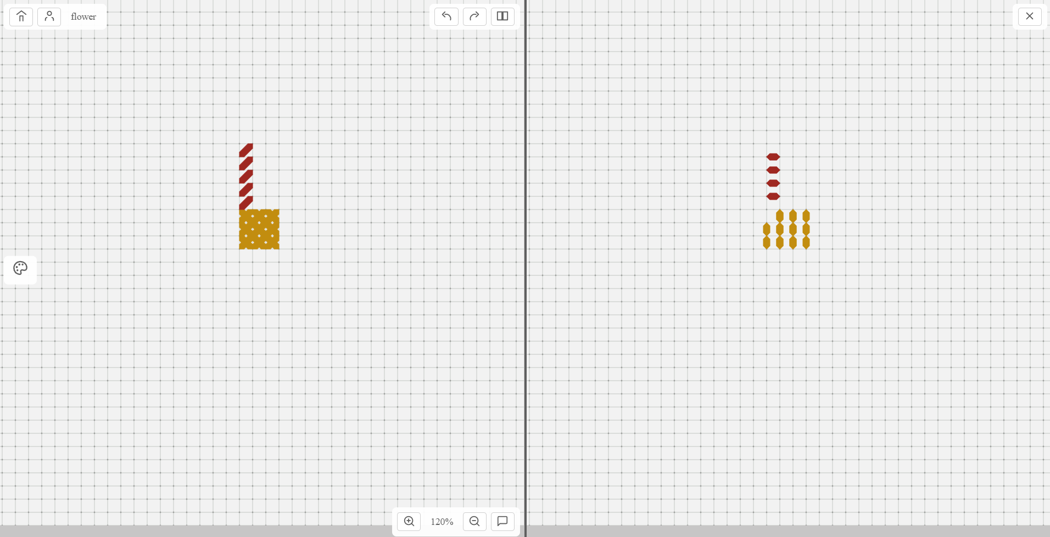
Figure 9

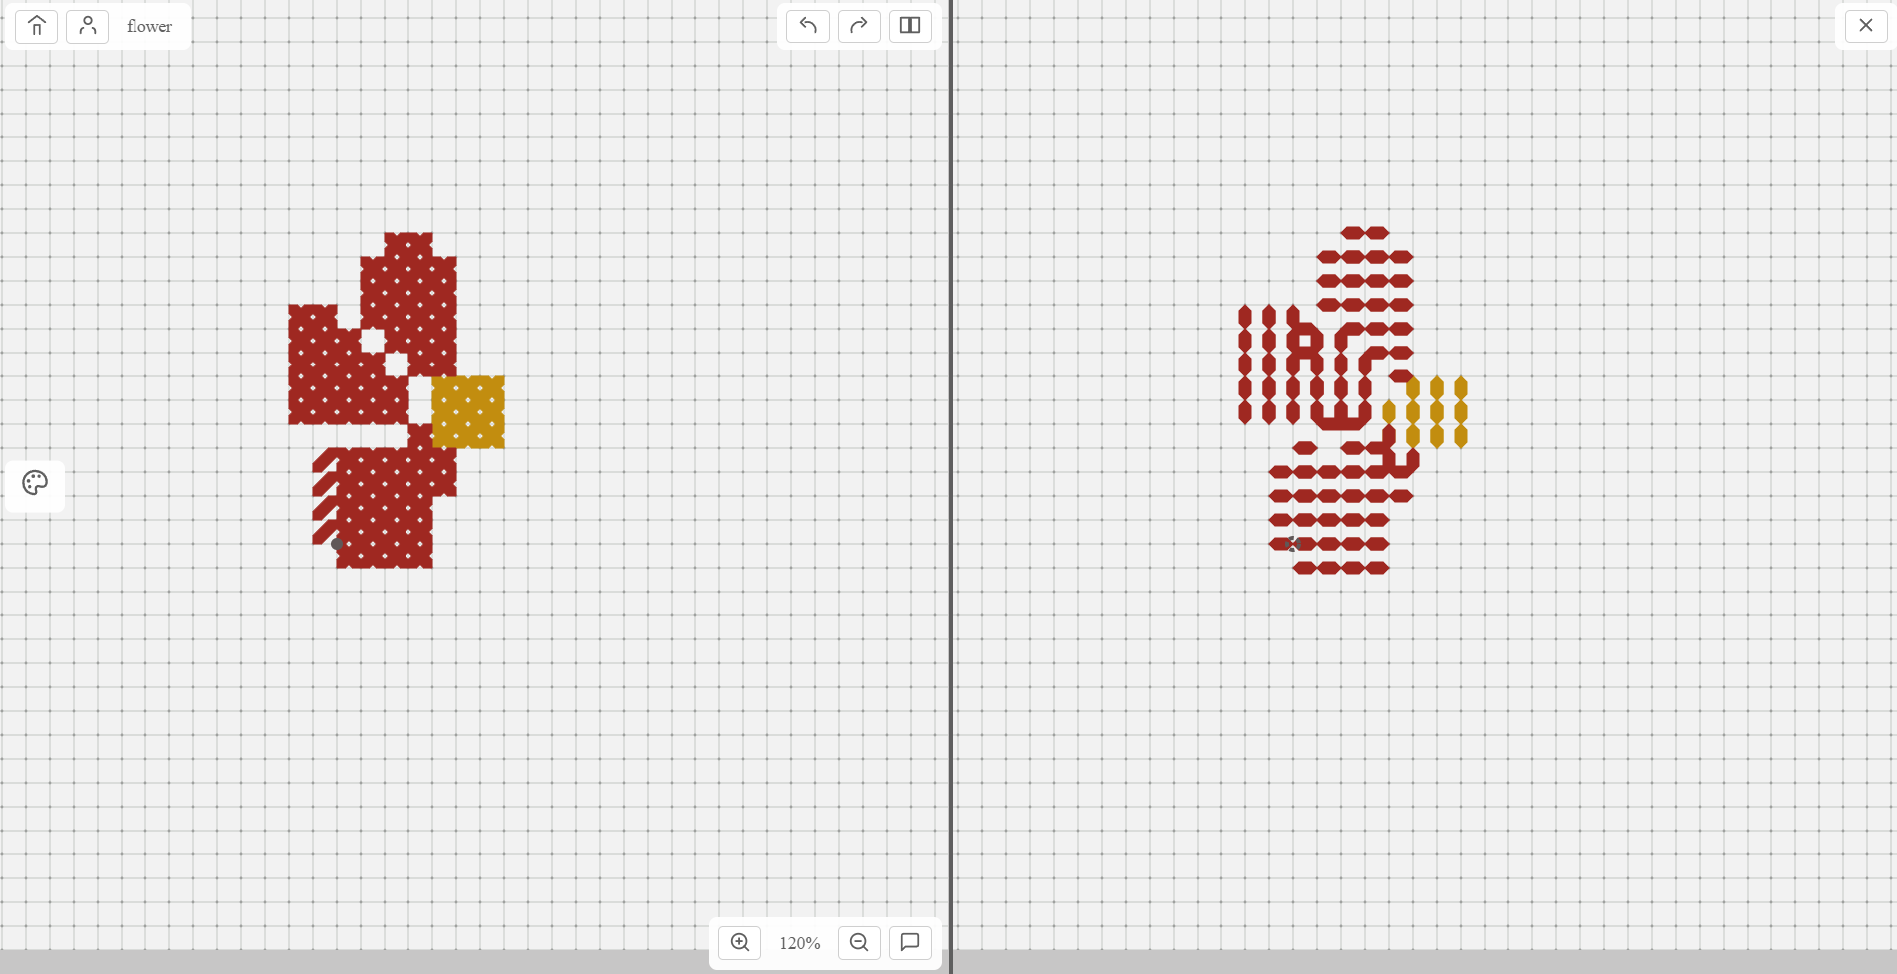
Figure 10

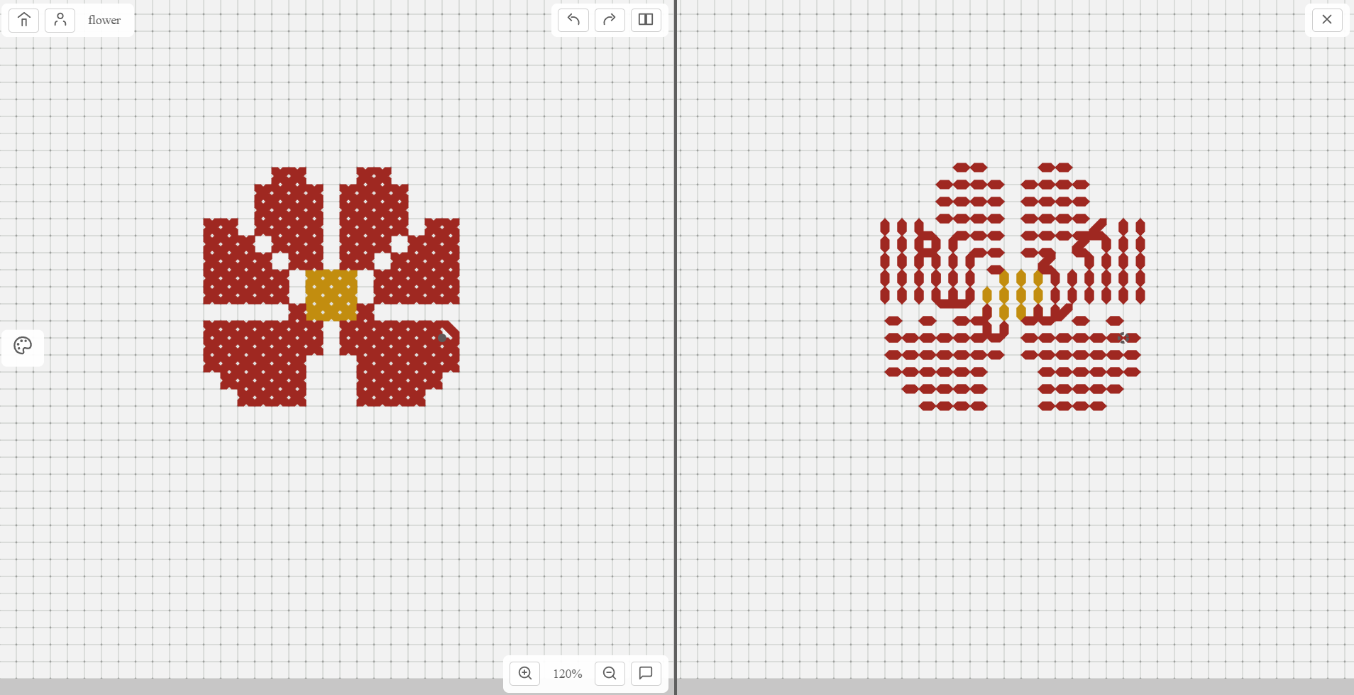
Figure 11

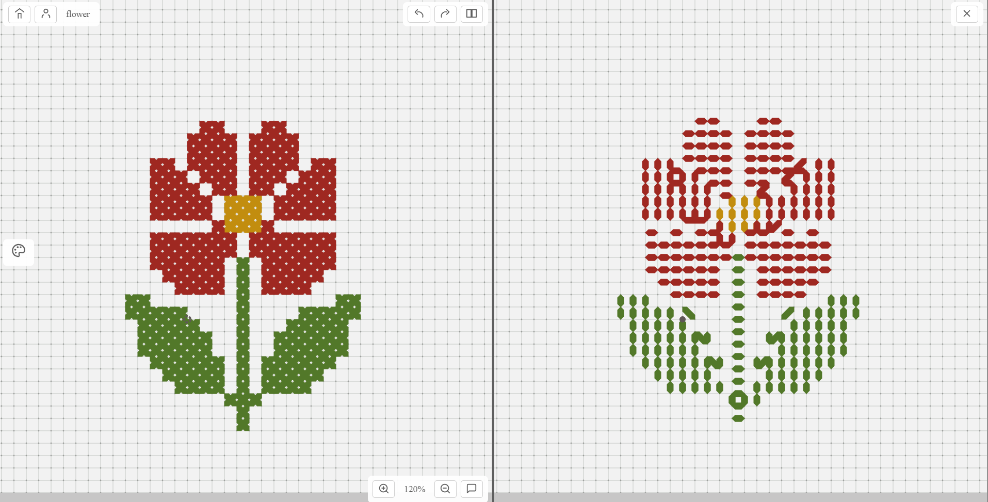
Figure 12

- Conclusion
To Be Done…

